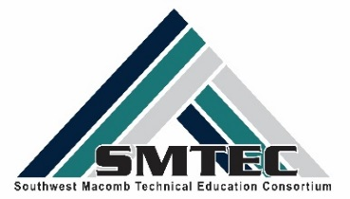
YEAR IN REVIEW 2016-2017

Points of Pride
Over 1700 students enrolled in CTE courses
New Programs approved in Marketing (CL) and Finance (FHS & WWT)
First US CTE Presidential Scholar Semi-Finalist
Four Breaking Traditions State Award Winners
First cohort of Early Middle College-Medical Assistant-18 students
One National HOSA Competitor in Physical Therapy
First West Point Cadet (ROTC)
Two NTHS National Scholarship Winners
Seven NTHS Seniors earned Graduation Stole and 3 earned Honor Cords
Five students earned the State of Michigan Certified Nurse Assistant License
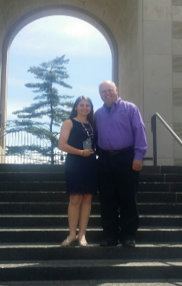
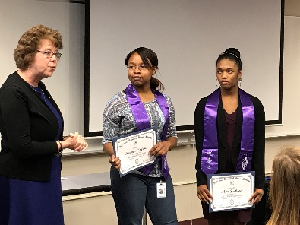

Scholarships- $6500 awarded for college
McLaren Pre Med Scholars-1 student-$1000
National Technical Honor Society-2 students-$1000
American Society of Body Engineers-1 student-$500
Macomb County Design Contest-1 student-$500
American Red Cross-1 student-$500
Michigan CPA Leadership Conference-1 student-$1000

College Readiness – Over 633 students completed college campus visits
Baker College-Clinton Township & Port Huron Campus
Culinary Institute of Michigan-Port Huron
Eastern Michigan University
Macomb Community College
Michigan State University
Wayne State University
University of Detroit-Mercy

Volunteer/Community Service – 85 students volunteered in their community
A Night to Shine
Gleaners Food Pantry
Salvation Army
Turning Points Fundraiser & Donation
Veterans Hospital-HOSA Leadership
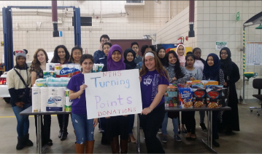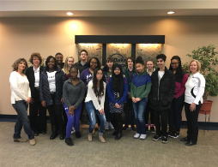

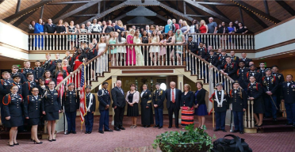
Career Readiness/Work-Based Learning Visits
Over 1400 students visits with 31 business partners
Auto STEAM Days @ Macomb Community College
C2 Pipeline @ Wayne State University
Ceratitid Company
City of Center Line
City of Sterling Heights Mass Casualty Drill
Career Fair in CAD & Manufacturing
Detroit Economic Club
Dining Out-ROTC
Eifel Mold & Engineering
Future Docs Participants @ Michigan State University
General Motors
Grant Group
Industry Source
Job Fair Participants-Health & Human Services Career Academy
Just Build It Workshop Participants @ Eastern Michigan University
Manufacturing in America
McLaren Pre Med Scholars Program
Michigan Defense Expo Exhibitors
Mobile Dentistry Unit
Morley Candy Factory
North American International Auto Show
Paragon Company
Selfridge Air National Guard
Shelby Crossing Assisted Living Center
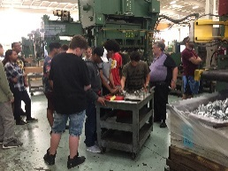
Somerset Mall Management
St. John Hospital
St. Louis University-Cadaver Demo
True Industries
US Army STEM Van
VA Hospital
Wright & Fillipis

Student Competitions – Over 360 students competed in CTE contests
American Society of Body Engineers Design Contest
Top Ten Award
Best of School Award
Detroit Center Line, 7th Brigade Drill Competitions
Meal Ready Competition with US Marine Corp
Michigan Schools & Government Credit Union Dessert Competition
Third Place-Warren Woods Tower Culinary Program
Michigan Schools & Government Credit Union Marketing Contest
First Place-Fitzgerald HS Team
North American International Auto Show Contest
HOSA Regional, State, & National Competitions
Τop Ten State Award & National Qualifier
Skills USA Regional & State Competition
Top Ten Leadership Award
Macomb County Friends of Diversity Logo Competition
First Place
Michigan Industrial Technology Education Society (MITES) Regional & State Competitions
Regional Grand Award Winners
Cosmetology Up Do & Fantasy Make-Up Contest

