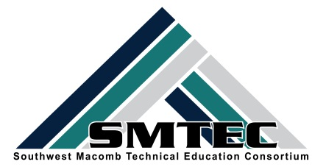
SMTEC SNAPSHOT
FRIDAY, JANUARY 6, 2017
Student News
- Congratulations to the JROTC Panther Drill Team who placed 3rd in the Detroit Statewide Drill Competition
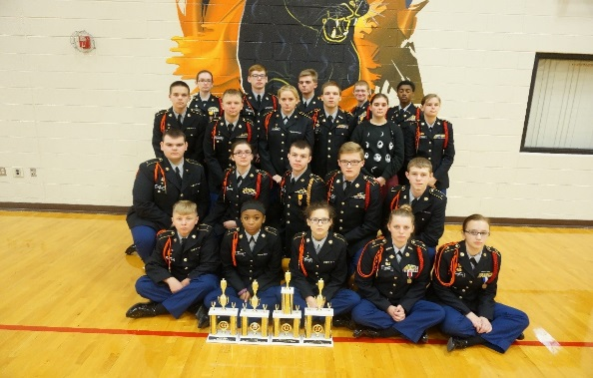

- Hats off to the Warren Woods Tower Culinary Program who earned Second Place in the Michigan Schools and Government Credit Union’s Annual Dessert Competition. Congratuations to both WWT and Lincoln teams on their delicious entries.
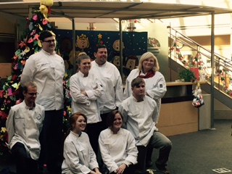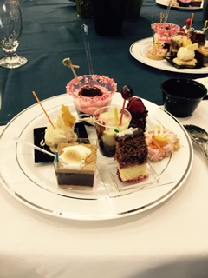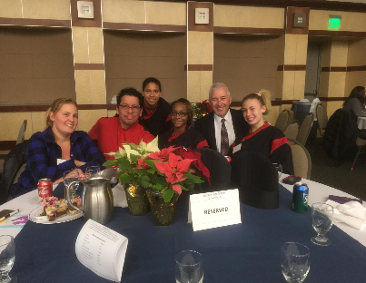
WWT Culinary Ms. Adams WWT- Winning Desserts LHS-Mr. Pius, Chef Herrera
Mr. Silwanowicz & Students & Students

- Congratulations to the following students on their nominations for Outstanding CTE Seniors and CTE Students. They will each be honored at the Feb. 3rd MCTEAA Breakfast at MISD.
Charles Debczak-CLHS Yousif Akoob-LHS
Matthew Collings-CLHS Brandon Wright-LHS
My Tran-FHS Khaila Rucker-WWTHS
Kenny Schumborg-FHS Yousif Tatar-WWTHS

- Wow! SMTEC Dental students are able to job shadow right in their own classroom as the Mobile Denistry Unit uses the LHS classroom as a clinic.
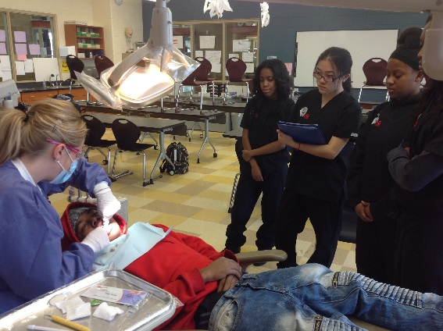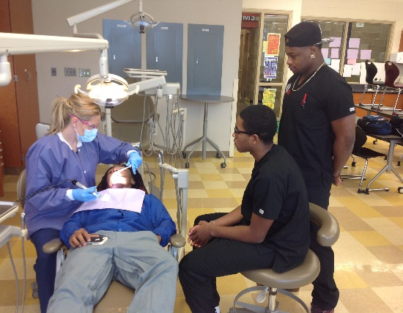

- SMTEC CAD students are using their problem-solving and entrepreneruial skills to solve problems and “make parts.” Pictured below is the “Analog Controller Extension” designed by Mitch McConville and also custom phone cases and key chaiins which can be ordered through the CAD classroom. Way to use your skills!
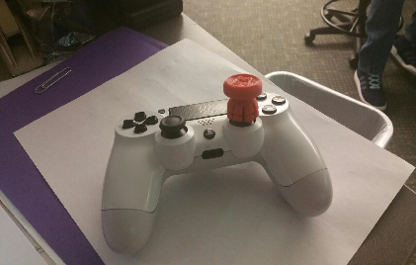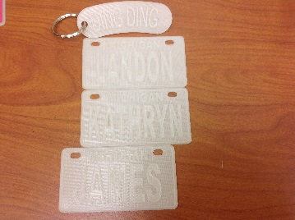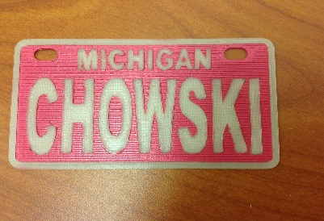

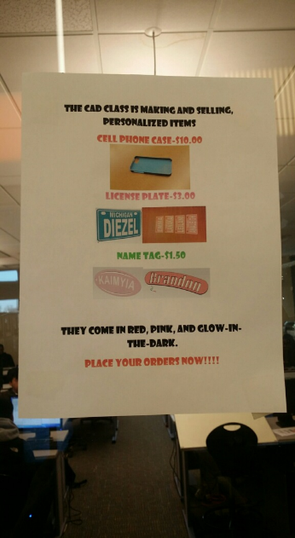

- SMTEC Manufacturing Tech student Austin Morse shows the part he made to assist in the re-design of the LHS BBQ grill. This inter-disciplinary project began with a request by the culinary students for an updated BBQ for school functions, moved onto the CAD classroom for design and onto Manufacturing to make parts, and then will finally move onto Auto for final renovations.

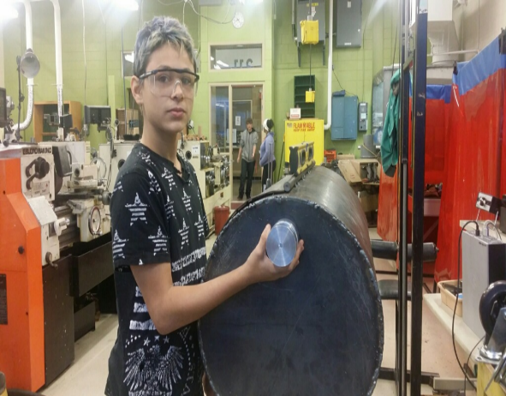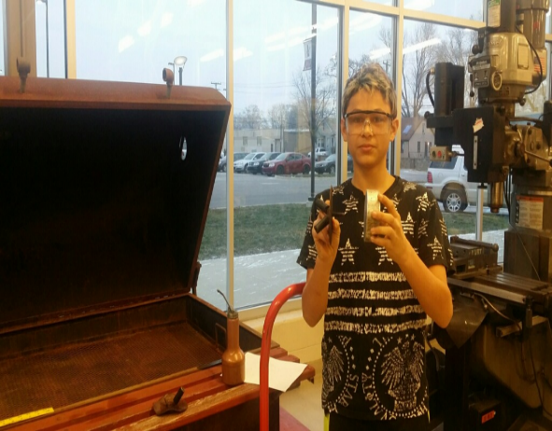

- Congratuations to the winners of the Cosmetology 1 Holiday Up Do Competition
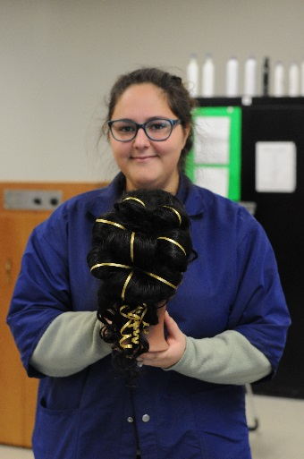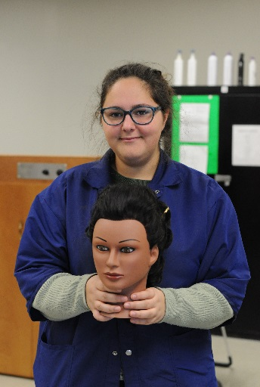
Miram Eldasr 1st Place-Mrs. Deddeh’s Class
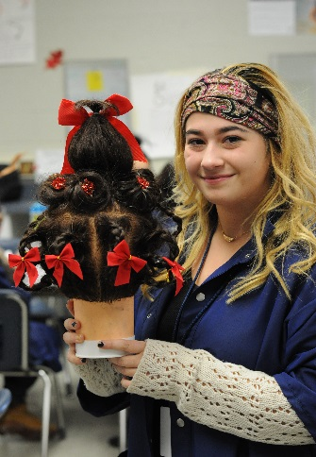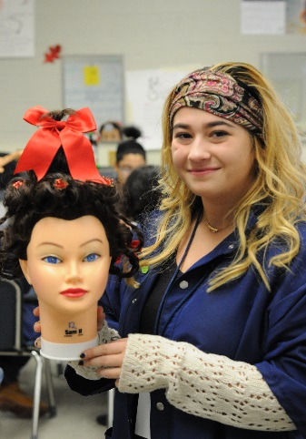
Kaylee Murphy 1st Place-Mrs. Ehrke’s Class
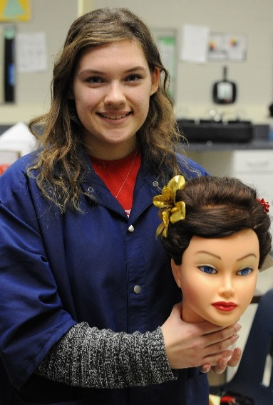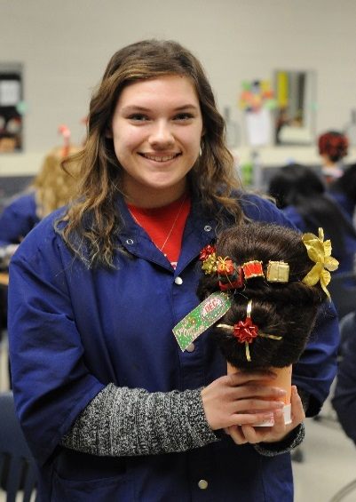
Jessica Verstraete 1st Place-Mrs. Mulder’s Class

Samah | Zokari | CL
Rachel | Evans | CL
Brooke | Popour | CL
Gabriell | Hayes | FHS
Cortney | Cooper | FHS
Tahmina | Islam | FHS
Latavia | Curtis | LHS
Zlayiah | Frazier | LHS
Betty | Morgan | WWT
Naheda | Musa | WWT
Olivia | Mausolf | WWT
Mariya | Benson | WWT
Alexis | Cerra | WWT
Andrea | Walker | WWT
Emily | Dempsey | WWT
Briana | Paval | WWT
Danielle | Damm | WWT
Megan | Januszkiewicz | WWT
Hayley | Moreton | WWT
Jaden | Tookes | WWT
- Congratualtions to the following students who have applied and been accepted to complete their clinical hours at Shelby Crossing for the Certified Nurse Assistant Program. Students will complete a minimum of 24 hours of hands-on work with patients in preparation for their national exam later in the year.

SMTEC News
- Congratulations to the following teachers on receiving approval from OCTE on their New Program Applications. Your dedication and commitment is appreciated!
Center Line Steve Sheardown Marketing
Donna Giacona Web Design

Fitzgerald Ken Krause Accounting

Lincoln Fred Cook Mechanical Drafting

Warren Woods Layla Kayyod Accounting

- Our SMTEC Making the Connection pages in the Macomb Daily have all run. Here is the link for their articles about the good things happening in CTE.

http://www.misd.net/careerteched/makingtheconnection.html

- Congratulations Ken Krause on the article in MoneySKILLMatters! 4th Quarter 2016 publication. Go to this link http://afsaef.org/Portals/0/2016_4Q-MSMatters-WEB2.pdf to read the interesting work Ken is doing in his classroom!
- Congratulations to Ms. Kayyod for her efforts in winning a grant from the Michigan Schools and Government Credit Union. The grant allowed her to purchase a coin-operated foosball table for the Campus Corner Store. Students can “drop by” and play a quick game during their lunch hour while they “browse the store” for Titan items! Nice Job!

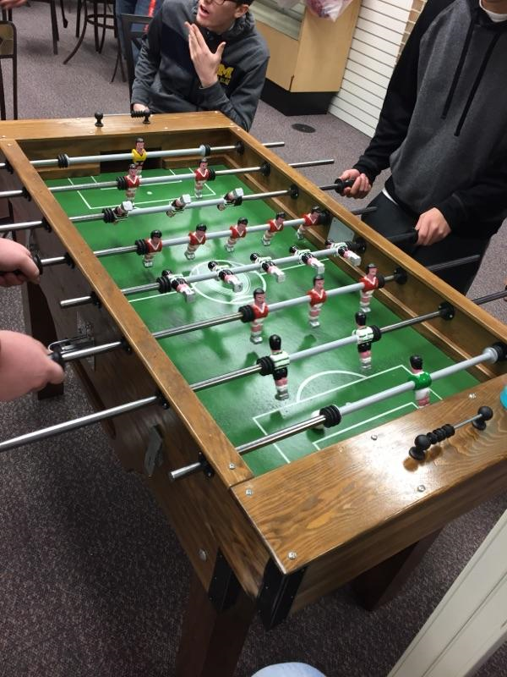

- SMTEC is launching their first Early Middle College Program that is directly connected with the SMTEC Medical Assistant Program. Students must be current 10th graders and will enroll for next year. Postcards were mailed to all SMTEC 10th grade students (SEE ATTACHED). We hope this is the first of many formalized post-secondary options for SMTEC students. Information meeting will be held at each school on the following dates:
  - CL-Feb. 9 @ 9:30
  - FHS-Feb. 8 @ 12:30
  - LHS-Feb. 7 @ 12:45
  - WWT-Feb. 14 @ 12:30

- NTHS is off and running with our first community service project for the year. You should have a large white box in your classroom as well as a poster. We are working with Turning Point in Mt. Clemens to collect donated items that they are greatly in need of. FHS is continuing their boxed cereal drive until the end of February so please encourage your staff and students to assist us in our efforts.

SMTEC Teachers
- CTE Month Activities are coming! We will continue our tradition of the weekly candy bar drawings for one student per week. Students who earn candy bars will be entered into a drawing to win a Kindle.
- CTE Month Board of Education Meetings will feature outstanding alumni and current students. Each program is expected to provide students to speak at the BOE meetings. Students should be prepared to speak for 1-3 minutes about the value of their program, career goals, and hands-on/favorite learning activities. The dates and times are listed below.
  - FHS-Thurs., Feb. 9 @ 7 pm
  - WWT-Mon., Feb. 13 @ 6 pm
  - LHS-Mon., Feb. 13 @ 6:45
  - CL-Mon., Feb. 27 @ 7 pm
- Looking for excellent non-traditional candidates in Auto, Culinary, CAD, Manufacturing, for our statewide Breaking Traditions Award. Please speak with students who you feel are deserving and willing to put in the effort to complete the nomination packet!
- Can you believe it?! It is course catalog time already. Please work with your SMTEC Advisor to review your course catalog description and make any changes necessary.
DUE DATE FOR CHANGES IS 1/31/17
- If you are looking for excellent, up-to-date information on CTE from a national perspective, please check out the website of the Association of Career and Technical Education found at: www.acteonline.org

Upcoming Dates
- Monday, Jan. 9-12:30-1:30-Cosmetology Teacher Meeting
- Wednesday, Jan. 11-1:30-3:30-SMTEC CTE PLC Meeting at WWT-Titan Terrace
- Saturday, Jan. 14-1:00-3:30-NTSH Gleaners Volunteer Activity
- Monday, Jan. 23-12:30-2:30-SMTEC Advisors Meeting-FHS Media Center
- Mon. & Tues., January 30-31-Michigan Career Education Conference-Detroit
- Thursday, Feb. 2-7:30-8:30-NTHS All Student Meeting at FHS-CTE Building
- Friday, Feb. 3-8:00-MCTEAA Outstanding CTE Student Award Breakfast-MISD
- Saturday, Feb. 3-Regional HOSA Competition-Fraser High School

