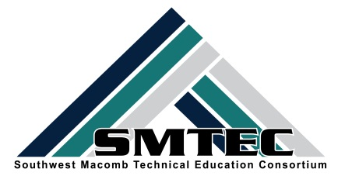
SMTEC SNAPSHOT
FRIDAY, NOVEMBER 4, 2016
Student News
- Congratulations to Brea Gosine and Ci Lee as they were recognized for their summer educational work at the Warren Woods Board of Education meeting and the Warren Weekly
http://www.candgnews.com/news/tower-medical-students-recognized-97187
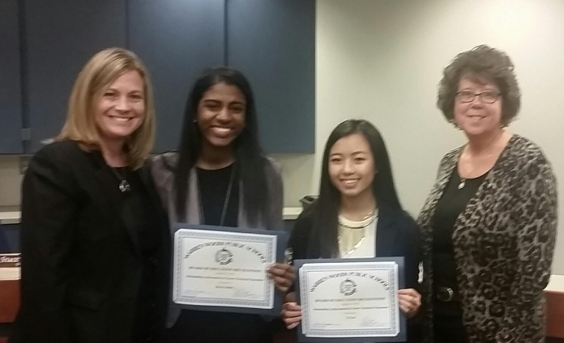

- Congratulations to the 28 students who applied to become members for the SMTEC National Technical Honor Society. This includes 16 new members from FHS, 10 from WWT, and 2 from Center Line. Our next meeting is Friday, Nov. 18th at the Warren Woods Educational Center from 1:45-5:33. Students have permission slips to ride the Cosmetology bus over and back to their home schools. This meeting will help us plan and implement our fall community service project.
 |  | Nicholas |  | Booza |  | CL | Trevor | Ajini | WWT
 |  | Melissa |  | Stein |  | CL | Aldrea | Caballero | WWT
 |  | Romana |  | Akter |  | FHS | Timothy | Eichman | WWT
 |  | Sarah |  | Butrus |  | FHS | Meghan | Januszkiewicz | WWT
 |  | Shereen |  | Choudhury |  | FHS | Ci | Lee | WWT
 |  | Kayla |  | Fleury |  | FHS | Nicholas | Pappas | WWT
 |  | Shyla |  | Flounory |  | FHS | Khaila | Rucker | WWT
 |  | Tahmina |  | Islam |  | FHS | Yousif | Tatar | WWT
 |  | Kimberly |  | Jackson |  | FHS | Jasmine | Vue | WWT
 |  | Khaya |  | Kabitaha |  | FHS | PadouaChe | Yang | WWT
 |  | Bre'Aunna |  | Keys |  | FHS
 |  | Kimberly |  | Lee |  | FHS
 |  | RL |  | Moore |  | FHS
 |  | Amran |  | Rahim |  | FHS
 |  | Afsana |  | Rahman |  | FHS
 |  | Zohura |  | Rahman |  | FHS
 |  | Tia |  | Seabrooks |  | FHS
 |  | Sydney |  | Wester |  | FHS
- SMTEC Health Science students can now apply for the MSU Future Docs Program. The application link is: http://www.com.msu.edu/Admissions/FutureDOcs/index.htm and is open from 11/1 to 12/16. Please take advantage of this wonderful opportunity to jumpstart your career with valuable summer experiences in the medical field!

- 60 SMTEC students recently attended the “Just Build It” Workshop sponsored by the Michigan Construction Association. Students went to Eastern Michigan University for a hands-on session to help introduce them to the many careers in the construction industry.
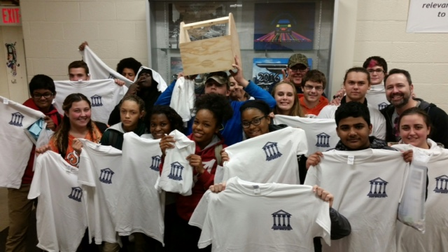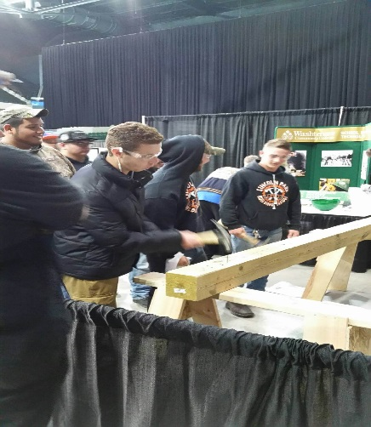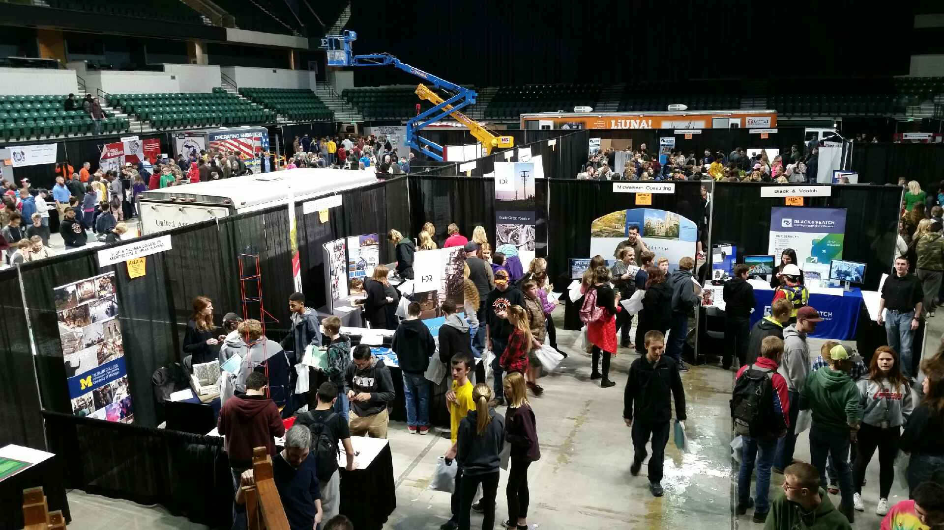
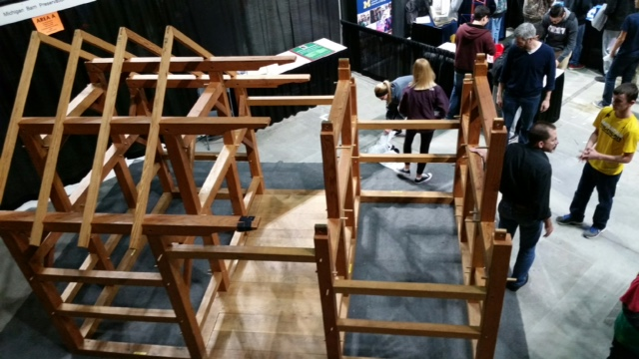

SMTEC News
- THANK YOU SMTEC TEACHERS AND STUDENTS FOR “BEING YOUR BEST” during our SMTEC CTE Bus Tour. We had the opportunity to show off our programs to counselors, administrators, and superintendents. They were very impressed with our classes. See below, a captive audience (seated in chairs on the right hand side of picture) learning movement in the SMTEC Physical Therapy classroom. Also, you can see Mr. Zainea sharing information about the many high-paying jobs available through the SMTEC Manufacturing programs.

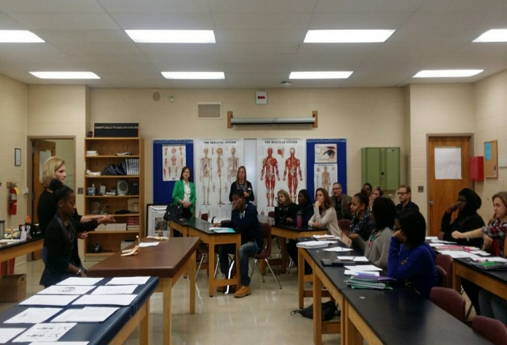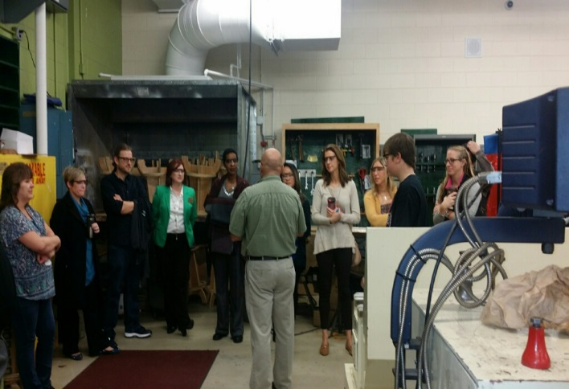

- SMTEC Advisors traveled to Detroit for a tour of Quicken Loans to learn about the many opportunities for young student interns. Quicken Loans hires both high school and college students for an 8-week summer internship. The application process is open and ongoing and students can apply at: http://www.quickenloanscareers.com/about-us/internship-program/
- WOW! SMTEC enrollment is up almost 10% this year from last year. On Count Day, we had 1739 students enrolled in CTE course compared to 1611 last year. Way to go SMTEC teachers!

SMTEC Teachers
- Now is the TIME to sign your students up for the respective CTSO. Remember, all CTE programs are required to annually “report” their leadership opportunities for students and one of the best ways is to enroll students in HOSA, BPA, DECA, Skills USA. For the past 2 years, SMTEC has sent a student to the national competition in HOSA. We would love to continue this tradition with other CTSOs. Registration will close soon.
- NEED BACK ASAP—Last call for your Wish Lists and PR Forms. We use these Wish Lists to draft preliminary purchase lists at each school in conjunction with your Business Managers and administrators. We are using the PR Form to work toward a Warren Weekly article on each program this year.

Upcoming Dates
- Monday, Nov. 7-4:00-5:30-Radio & TV Advisory meeting at FHS
- Tuesday, Nov. 15-8:00-1:00-HOSA Med Talks at MCC Performing Arts Center
- Wednesday, Nov. 16-Apple Days-Wayne State University Health Science Students
- Wednesday, Nov. 16-PD for Accounting & Marketing teachers-CLHS-PM
- Friday, Nov. 18-MCC College visit-WWT Health Science students
- Friday, Nov. 18-1:45-5:33-NTHS Meeting at Warren Woods Ed Center-Take COS Bus
- Monday, Nov. 21-SMTEC Advisors Meeting @ IBEW Training Facility, Warren
- Monday, Nov. 28-12:30-1:30-Cosmetology Teacher Meeting

K:\District\SMTEC\16-17-Snapshot\Snapshot-11-4-16.docx

