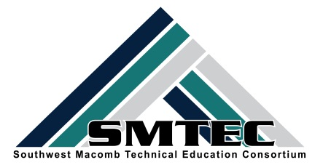
SMTEC SNAPSHOT
FRIDAY, DECEMBER 2, 2016
Student News
- NTHS students met together to plan out our year and launch our first community service project with Turning Point. See the fun and hard work in the pictures below.
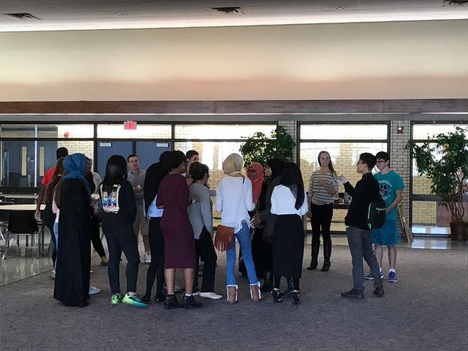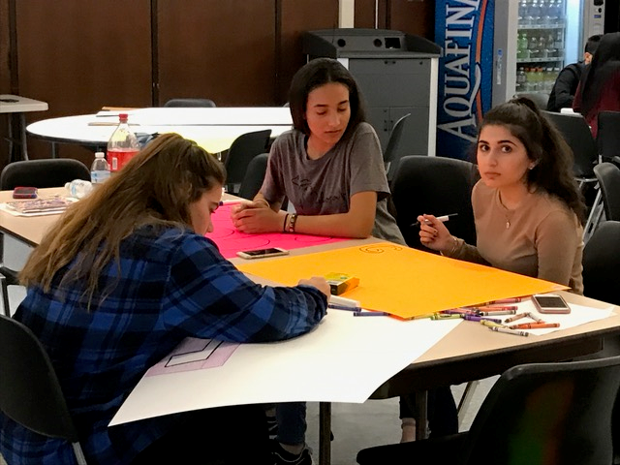

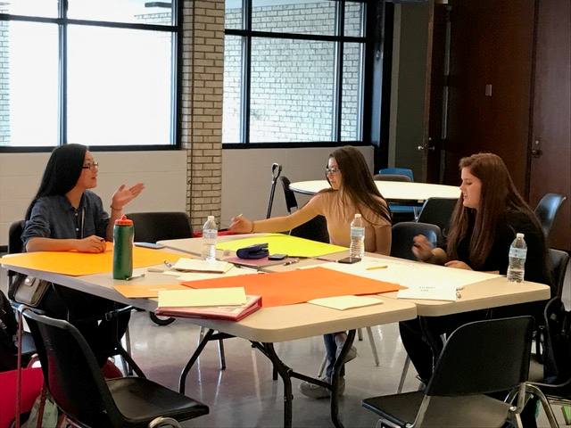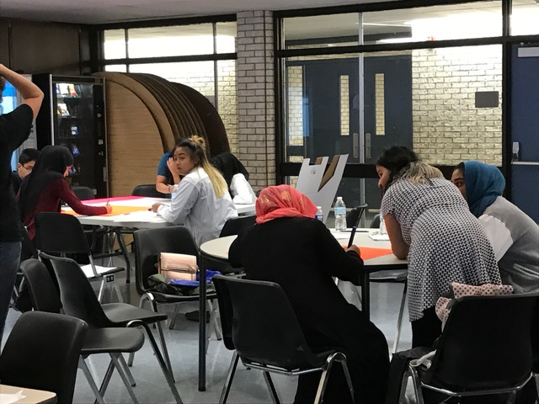

- LHS Culinary Arts Program hosted their annual “MRE” (Meal Ready to Eat) Competition. They work with U.S. military personnel to create more flavorful “MREs” which are judged by military personnel.
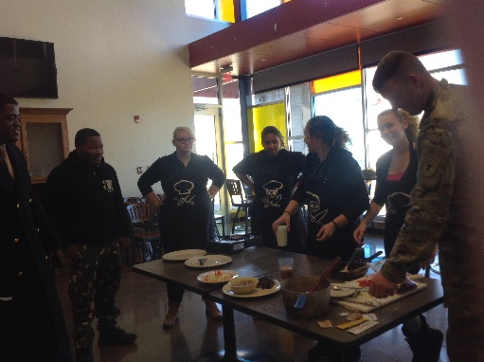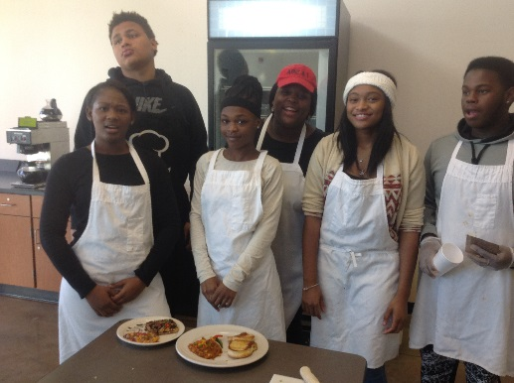

- Second year Cosmetology students participate in their annual “Fantasy Make-Up” Competiton. Winners (from left to right) are: Jaden V. (model) and Tori T (artist), Fire P and Cameron M. (models) and Kelsey C. (artist).
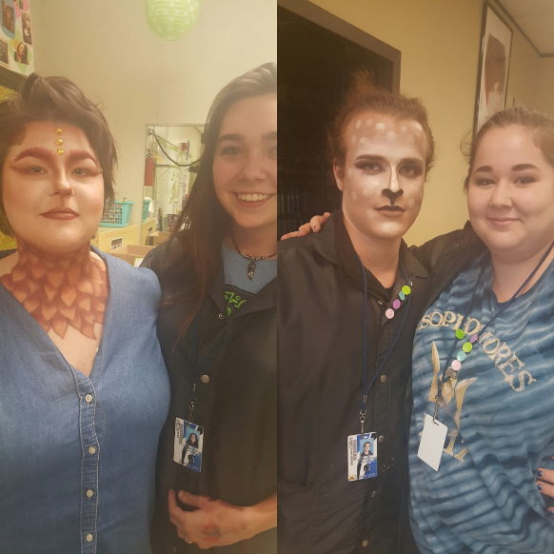

- SMTECs JRTOC program utilized the Army STEM Van that allowed students to simulate various real world military similations.
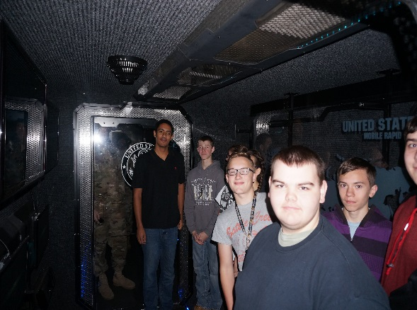
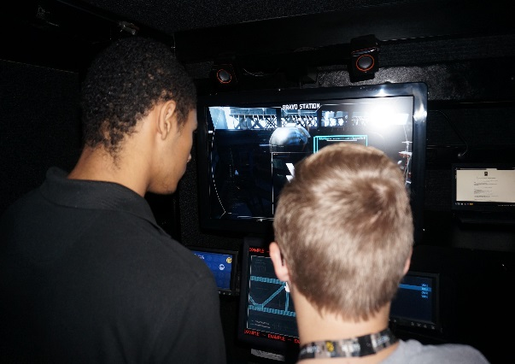

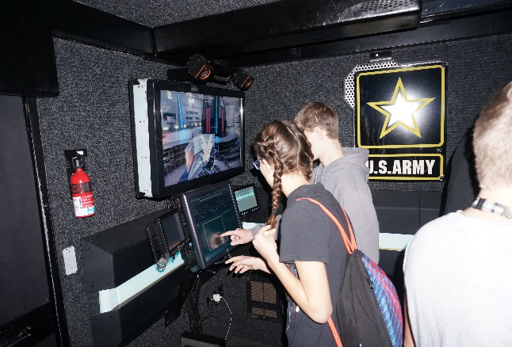

SMTEC News
- Welcome, Sgt. Dials, as a new full-time ROTC teacher for the SMTEC JROCT program. Although he has been working with the program since last year, he is now officially “on board.”
- SMTEC Advisors recently met at the IBEW Training Facility in Warren to explore ways to connect students to apprenticeship opportunities. Interested students should have at least a 2.5 GPA in Algebra and can find more information at www.MUSTcareers.org or www.detroiteitc.org
- Thank you to the following teachers for their efforts in completing the OCTE New Program Application Process. We hope all these programs are approved and should know by early February.
Center Line Steve Sheardown Marketing
Donna Giacona Web Design

Fitzgerald Ken Krause Accounting
Brooke Smith Radio & TV

Lincoln Fred Cook Mechanical Drafting

Warren Woods Layla Kayyod Accounting
Eric Martin Radio & TV

- Our first Making the Connection page in the Macomb Daily “rolled off the press” on December 1st. Here is the link for the Center Line article about the good things happening in CTE. http://www.misd.net/careerteched/MakingtheConnection1/2016CTCenterline12-1-16.pdf

- NTHS is off and running with our first community service project for the year. You should have a large white box in your classroom as well as a poster. We are working with Turning Point in Mt. Clemens to collect donated items that they are greatly in need of. These donations will be collected up until our holiday break (Dec 20-21). Please encourage your staff and students to assist us in our efforts. The following collections are taking place:
  - Center Line Board Game donation for children and families
  - Fitzgerald Boxed cereal drive
  - Lincoln Boxed cereal drive
  - WWT Toilet paper

SMTEC Teachers
- MCTEAA Outstanding Students Award Nominations are due to the SMTEC Office by Dec. 9th. Please see your SMTEC Advisor to nominate an Outstanding Senior, an Outstanding Special Pops student, and an Outstanding Business partner. They will be honored at the MCTEAA Breakfast on Friday, Feb. 3rd at MISD.
- We have a new MISD CTE Consultant! Please welcome Shannon Williams, formerly CTE Director in Utica Schools. Shannon will join us officially on Jan. 23 and brings several years of CTE teaching and administrative experience to her position.

- If you are looking for excellent, up-to-date information on CTE from a national perspective, please check out the website of the Association of Career and Technical Education found at: www.acteonline.org
- For teachers with non-traditional students, you will be receiving a list of those students eligible for the state-wide Breaking Traditions Award. Please consider nominating a student for this exemplary award.

SMTEC Resources
- Please share this resource with counselors, colleagues, and parents and students who may be interested in the skilled trades area to allow students to explore these high-wage, high-demand areas: www.MITradeSchool.org

Upcoming Dates
- Saturday, Dec. 3-9:00-11:30-NTHS Volunteering at Gleaners in Warren
- Wednesday, Dec. 7-11:30-1:00-MSGCU Dessert Competition @ MISD
- Thursday, Dec. 8th-2:00-8:00-NTHS Volunteering at Salvation Army, Warren
- Monday, Dec. 19-7:30-8:30-NTHS-FHS Only Meeting @ FHS CTE
- Monday, Dec. 19-9:20-10:10-NTHS-CL Only Meeting @ CLHS Main Office Conference Room
- Monday, Dec. 19-10:40-11:20-NTHS-LHS Only Meeting @ Dental Classroom
- Tuesday, Dec. 20-4th Hour Lunch-NTHS-WWT Only Meeting @ Titan Terrace

K:\District\SMTEC\16-17-Snapshot\Snapshot-12-2-16.docx

