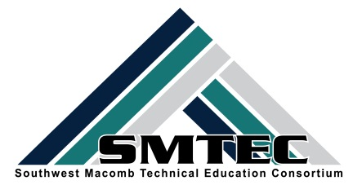
SMTEC SNAPSHOT
FRIDAY, FEBRUARY 17, 2017
February is CTE Month!
Student News
- Congratulations Brea Gosine-Michigan nominee for US CTE Presidential Scholar Award! Good Luck Brea!
- Congratulations to Ci Lee who successfully completed the first round for the WSU MedSchool Direct Program. Good Luck with the next step!
- Congratulations to our SMTEC Breaking Traditions nominees:
    - Heaven Lipford-LHS CAD
    - Brandy Blocton-LHS Manufacturing
    - Erin Portalski-WWT Law Enforcement
    - Tiffany Morgan-FHS Auto Tech
- Congratulations to MSU Future Docs students:
    - Antanasia Hardy-CLHS MA Program
    - Hira Khan-CLHS Pharmacy Program
    - Shyla Flourny-FHS Pharmacy Program
    - Satina Zeetow-FHS PT/Pharmacy Program
    - Zohura Rahman-FHS Pharmacy Program
- Congratulations to our MCTEAA Outstanding CTE Students

CLHS-Charles Debczak and Matthew Collins(not pictured)
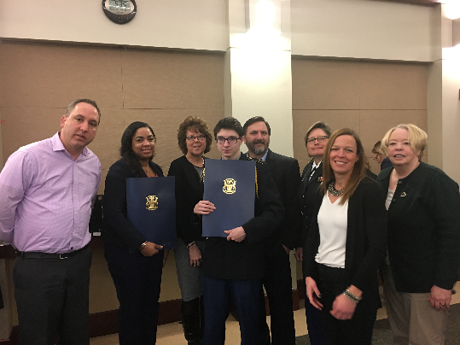

FHS-Kenny Schumborg (not pictured) and My Tran
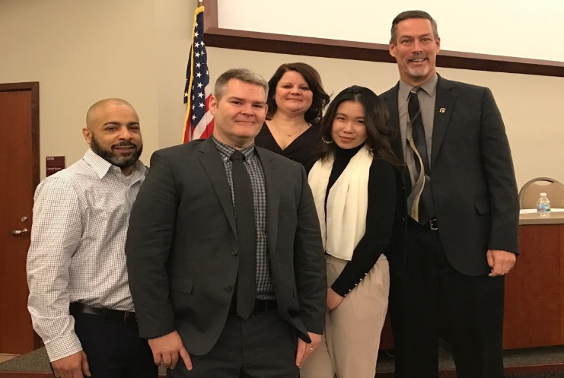

LHS-Yousif Akoob and Brandon Wright
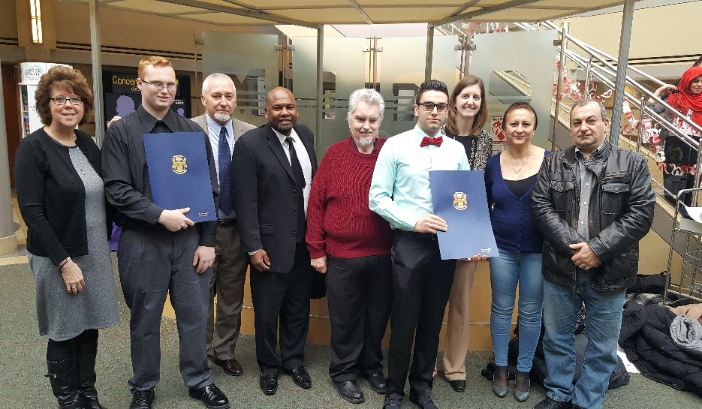

WWTHS-Khaila Rucker and Yousif Tatar
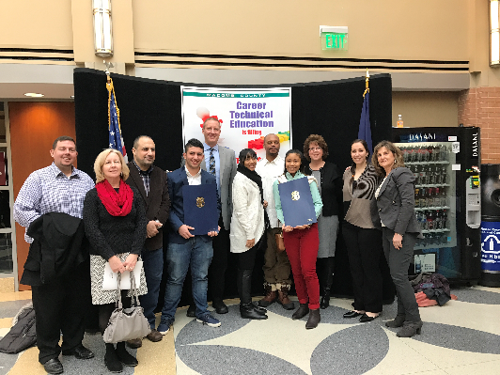

- Thank YOU Cosmetology II students for volunteering at “A Night to Shine!”
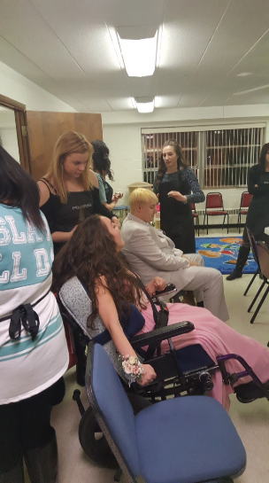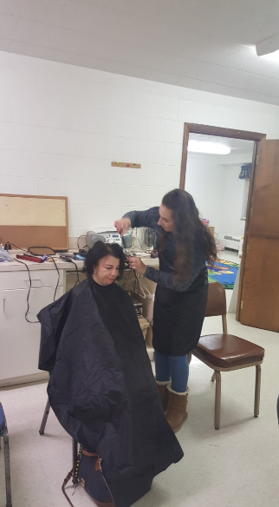

SMTEC News
- NTHS completed their fall community service project. Look what we donated to Turning Points in Mt. Clemens. Thanks to the AWESOME NTHS students who worked hard to make this happen!
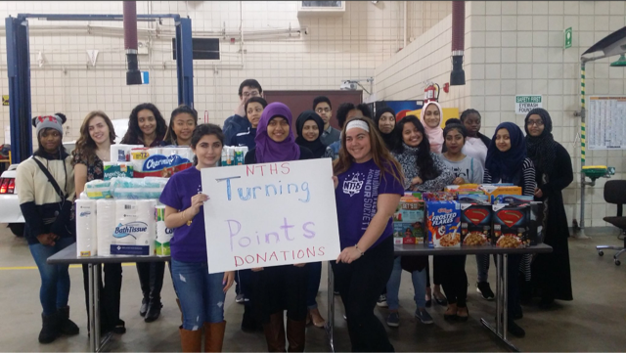

- NTHS is running their CTE Month Community Service Project. All CTE teachers should have a large white box in your classroom as well as a poster. We are working with Turning Point in Mt. Clemens to collect donated our jeans, which serve local Macomb County families. HELP US BEAT OUR RECORD FROM LAST YEAR—153 JEANS!

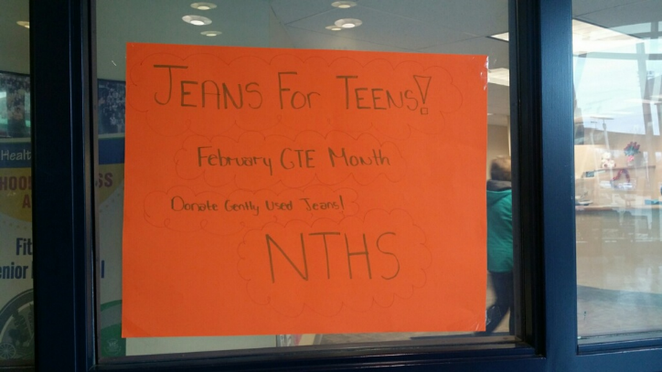

- Next NTHS Meeting for ALL students will be at FHS CTE Building on Mon. 2/27 at 7:30 am. WWT and CL and LHS students, please take consortium bus over. See your permission slips for time and bus location!
- Thank You to the students and teachers who shared their “CTE stories” at the Board of Education meetings. The board members and administrators are SO VERY IMPRESSED with what we are accomplishing every day with students.

Thanks to the following from FHS
Edward Brown Janee Brewer Farjana Lavlu Santina Zeetow
Nazim Ullah Joseph Jean-Baptiste My Tran
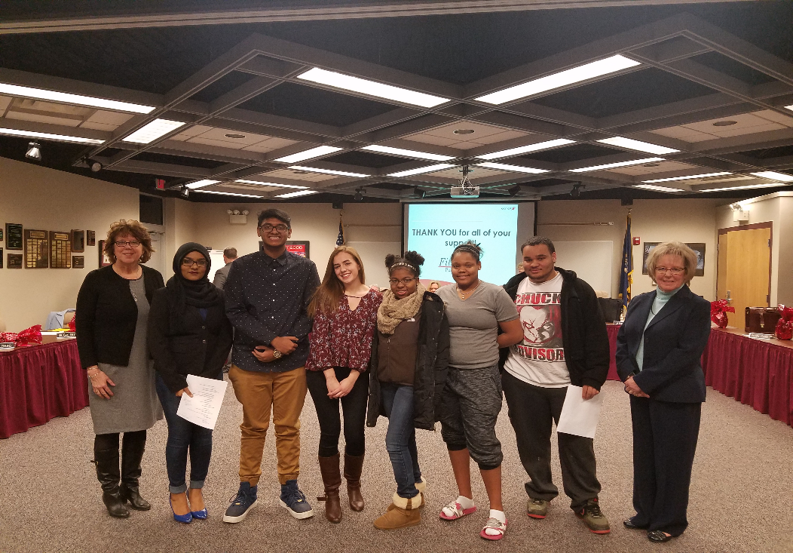

Thanks to the following from WWT
Erin Portalski Trevor Agini Kayla Dempsey Emily Dempsey
Anthony Coscione Amia Brown Samantha Hunt Brianna Paval 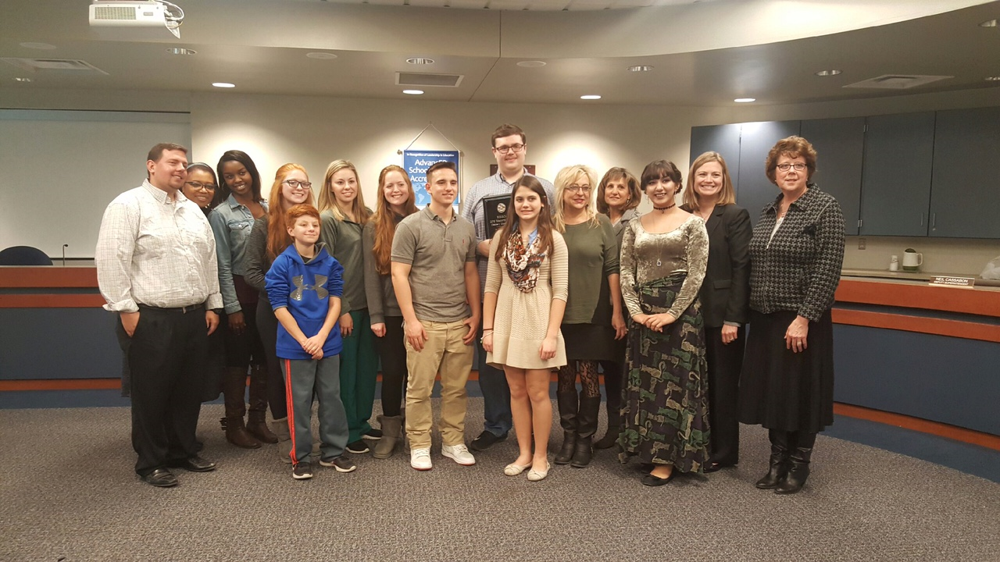

Thanks to the following from LHS
Sara Lee Yousif Akoob Thomas Dixon Heaven Lipford Charles Page Kyle Ford
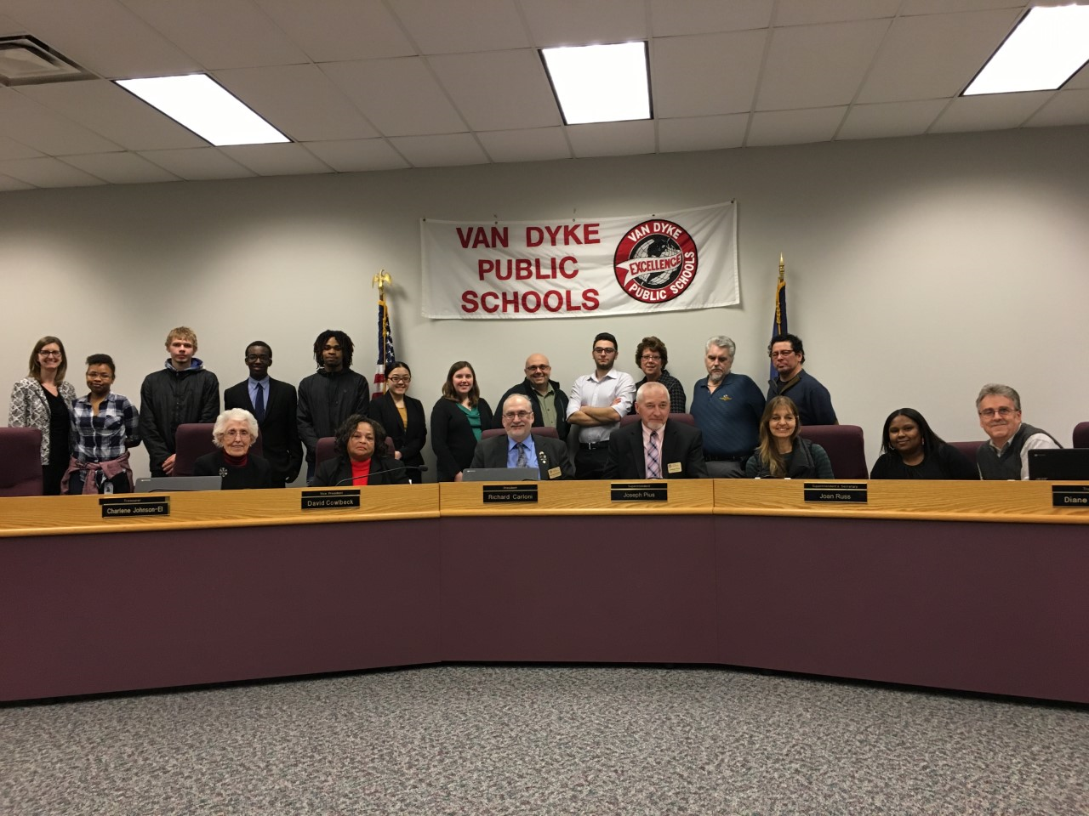

SMTEC Teachers
- CTE Month Activities are coming! We will continue our tradition of the weekly candy bar drawings for one student per week. Students who earn candy bars will be entered into a drawing to win a Kindle. Please send your slips to Cindy in the SMTEC Office.
- Please circulate these two scholarship opportunities for students. The first is sponsored by the MSGCU http://www.msgcuscholarships.org/
- The link for the Marine Corps Scholarship Foundation for CTE students (you do not have to be entering the military to be eligible) can be found at: https://www.mcsf.org/cte/

CTE Resources
- Please take a moment to read this short, but informative article on CTE. Even better, share it with a “non-CTE” colleague to help others understand the value of CTE programs. It is entitled “CTE in High School: Does It Improve Student Outcomes?” and can be found at: http://www.ascd.org/ascd-express/vol12/1209-dougherty.aspx
- Check out these FREE resources shared by Ken Krause. Thanks for sharing Ken! http://everfi.com/k12/
- Governor Snyder budget proposes $20 million to help K-12 purchase CTE equipment. See the article in Crain’s Detroit Business found at: http://www.crainsdetroit.com/article/20170212/NEWS/170219971/snyder-proposes-20-million-to-help-k-12-vocational-schools-buy
- One more resource shared by OCTE—Learning That Works Resource Center at: https://careertech.org/resource-center

Upcoming Dates
- Thursday, Feb. 23-LHS-CTE Open House—5-6:30 p.m.
- Saturday, Feb. 25-9:00-11:30-NTHS Gleaners Volunteering
- Monday, Feb. 27-Center Line CTE Month BOE Meeting-7 p.m.
- Wednesday, Feb. 28-Deadline for Early College applications - Medical Assisting Program

K:\District\SMTEC\16-17-Snapshot\Snapshot-2-17-17.docx

