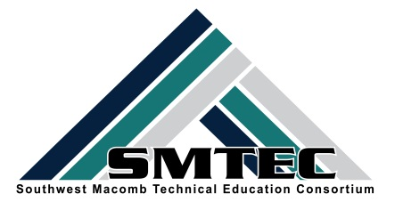
SMTEC SNAPSHOT
FRIDAY, APRIL 28, 2017

Student News
- Congratulations Brea Gosine-Michigan SEMI-FINALIST for US CTE Presidential Scholar Award!
- Congratulations to Ci Lee who has been accepted to Stanford!
- Congratulations to Breaking Traditions Merit Award Winner: Erin Portalski (WWT) Law Enforcement @ CLHS
- Congratulations to Breaking Traditions Award Certificate Winners: Tiffany Morgan (FHS) Auto Tech, Brandy Blocton, Manufacturing @ LHS, Heaven Lipford, CAD @ LHS
- Congratulations to our CTE Kindle Winners:
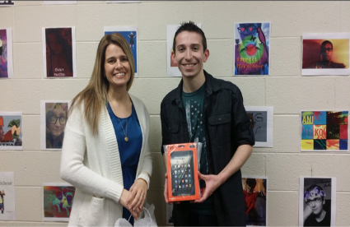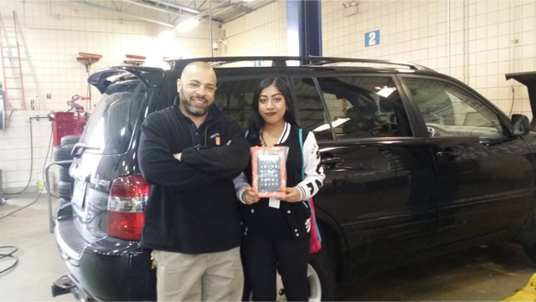
Dylan Clark-Center Line High School Taslima Miah-Fitzgerald High School
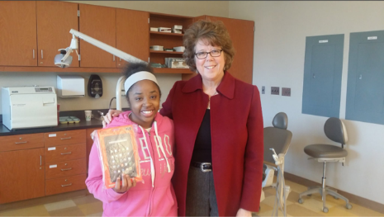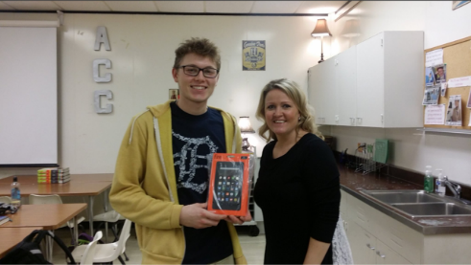
Brianna Ruggero-Lincoln High School Christian Dolunt-Tower

- Congrats to the JROTC on their fabulous Dining Out Experience
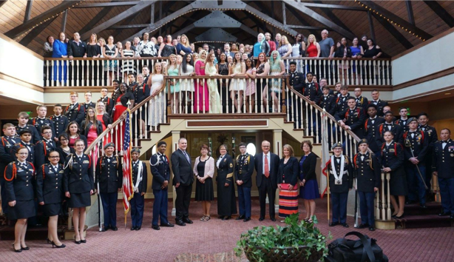

- Congrats to Matthew Prisco, FHS Accounting student who won a scholarship from the Michigan Assn. of CPAs at their Student Leadership Conference
- Congrats to SMTEC CAD and CL Robotics students for demonstrating their skills at the Michigan Defense Expo. They even enjoyed a visit with Lt. Governor Calley!
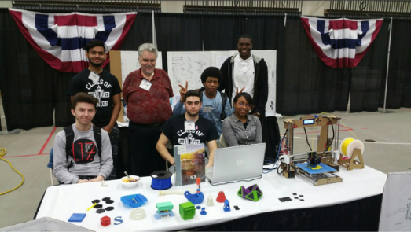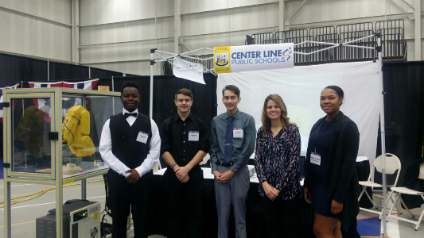
Lincoln High School Center Line High School

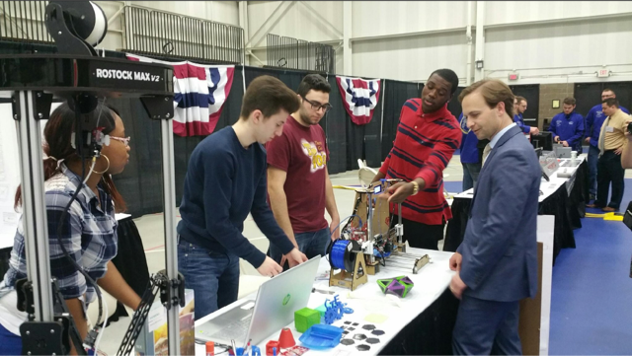
Lincoln students with Lt. Governor Calley

- Hats off to our first Early Middle College-Medical Assistant cohort group!
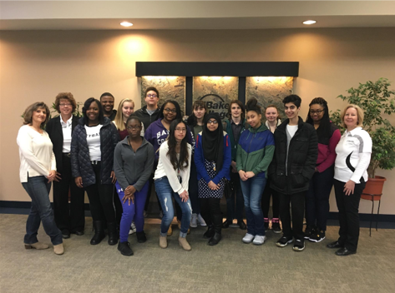

- Congrats to ASBE Winners Yousif Akoob, Top 10 and MCC Tuition Scholarship Winner and Tawsif Tajwar, Best of School Award.
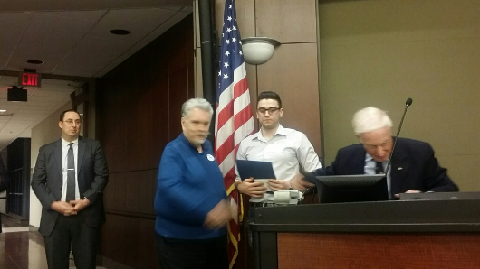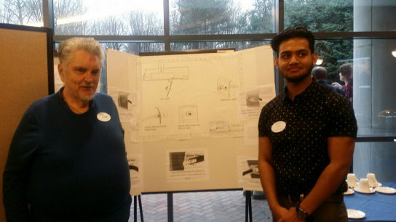

- Hats off to Theresa Khouri, who has started volunteering at St. John Macomb Hospital
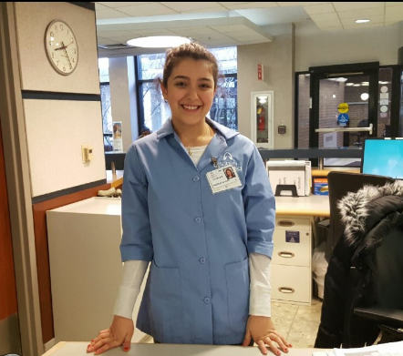
- Thank YOU Cosmetology I students for your generous donation of $412.18 to Turning Point WOW! What an awesome Penny War competition!
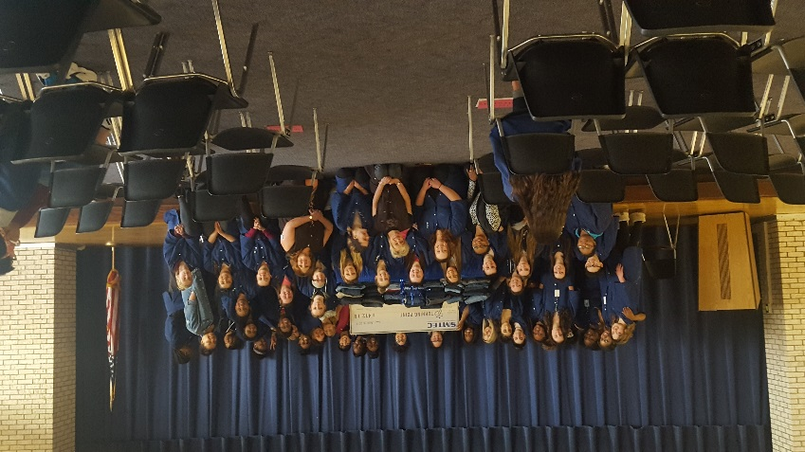
- Congrats to Charles Debczak on his acceptance to West Point!
- Thanks to the students and teachers who presented at the CLPS Board of Education Meeting for CTE Month. They were Derek Jones, Andrew Belkowski, Charles Debczak, Kiahna Cook, Brooke Popour, Destiny Smith, Melissa Stein and Nick Booza
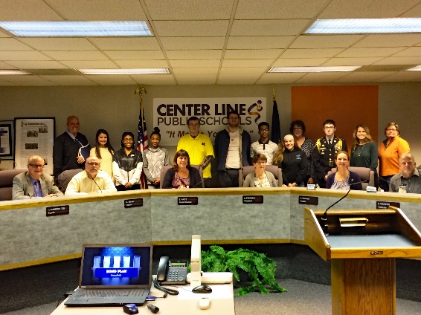

SMTEC News
- NTHS completed their spring community service project and donated 53 pairs of jeans to Turning Point in Mt. Clemens.
- SMTEC EMT students participated in a Mass Casualty Drill with the City of Sterling Heights
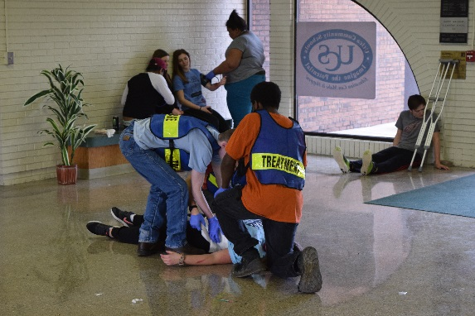
- HOSA Officers volunteered their time at the VA Hospital
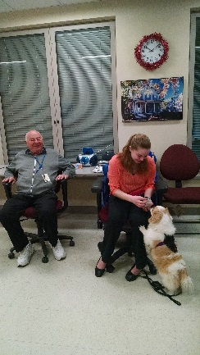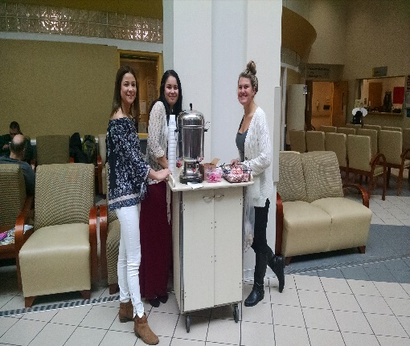
- Congrats to the JROTC Panther Battalion for their outstanding performance at the 7th Brigade Memorial Invitational in Kentucky. The Rifle Team of Tyler Wright, Daniel Kremhelmer, Gaige Schienle, and Ryan Miner finished 43rd out of 98 teams. The Academic Team did well with Charles Debczak placing 5th, Sarah Sharles 8th, and Ryan Miner 22nd in a pool of over 500 cadets.
SMTEC Teachers
- Reminder—CIP Self Review in Navigator must be completed by 5/26/17. Please email me if you need assistance.
- Reminder—Spring Advisory Meetings must be scheduled. Need help, please ask!
- Please circulate this scholarship to students interested in computer science. While we do not have CTE programs, I hope you know someone who may be interested in applying.
https://www.grandcircus.co/develop-the-mitten/

CTE Resources
- Please take a few minutes to read this short, but excellent article on recent research with CTE graduates in Arkansas.
http://www.ascd.org/ascd-express/vol12/1209-dougherty.aspx

Upcoming Dates
- May 3rd-LHS Career Fair for CAD & Manufacturing seniors
- May 3rd-MSGCU Marketing Competition
- May 3-FHS CTE PLC Meeting-1-2:30
- May 4th-CLPS/CTE Academy Advisory Board Meeting-9:30 am
- May 8th-Cosmetology Advisory Meeting-11:30-12:30
- May 11th-Breaking Traditions Award Ceremony-Michigan Historical Library, Lansing
- May 11th-Business, Marketing, Finance Advisory Meeting at Extra Credit Union-3:30
- May 12th-Physical Therapy fieldtrip to Wright & Phillipis
- May 15th-SMTEC Advisor’s Meeting
- May 16th-CLHS ITI Academy Job Day for all juniors & seniors-8:00-1:30-CINDY-FLYER HERE
- May 17th-CLHS CTE PLC Meeting-1:2:30
- May 17th-JROTC Advisory Meeting-3-5 pm
- May 17th-Cosmetology Parent Meeting @ Ed Center-6-7:30
- May 18th-Wayne State University-Nursing & Engineering fieldtrip
- May 19th-NTHS Induction & Award Ceremony-FHS CTE Building-7:30-9:00 am
- May 22nd-COS meeting-12:30
- May 19th-Selfridge fieldtrip
- May 31st-Cosmetology Parent Meeting @ Ed Center-6-7:30

K:\District\SMTEC\16-17-Snapshot\Snapshot-2-17-17.docx

