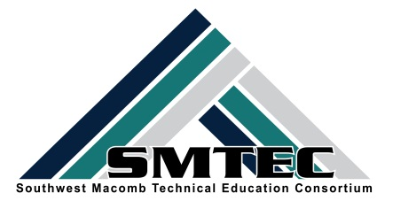
SMTEC SNAPSHOT
Thursday, MAY 18, 2017

Student News
- Congratulations to Breaking Traditions Merit Award Winner: Erin Portalski (WWT) Law Enforcement @ CLHS
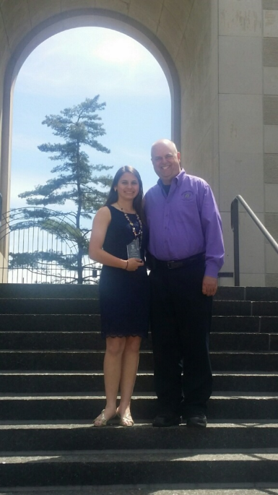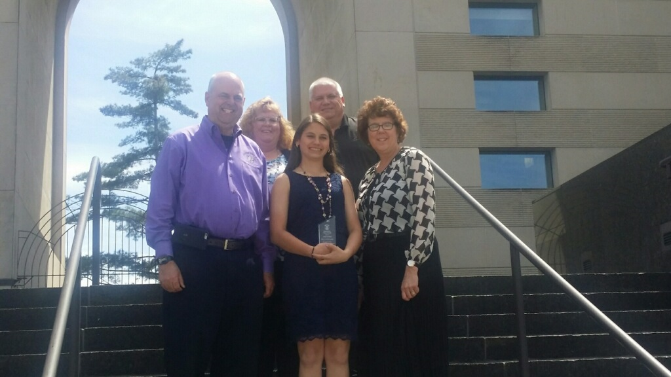

- WOW! Ranithia Mitchell qualified for the HOSA International Leadership Conference at Disney Resort in Orlando in June. She is the first PT student to qualify and we are excited to send her to represent PT, SMTEC, and FHS. Good Luck Ranithia! (LEFT) Congrats also to Shyla Flounory on her Top 8 Award in Physical Therapy at the HOSA State Leadership Conference.
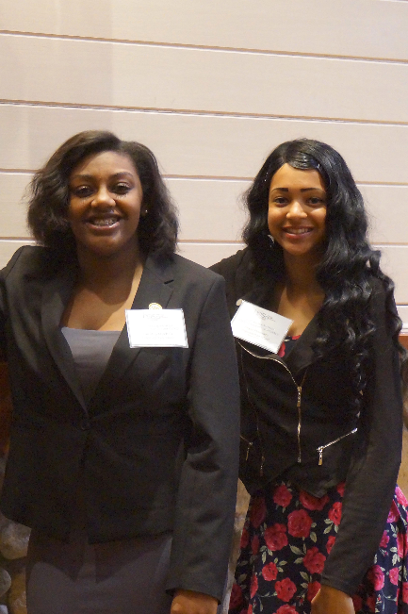

- Congrats to Alesia Yang on her award-winning logo for the “Friends of Diversity and Inclusion” contest open to all Macomb County High School students. Alesia won $500.
- Congrats to our MITES Regional Grand Award Winner, Bradley Wojt (10thgrade) from Manufacturing.
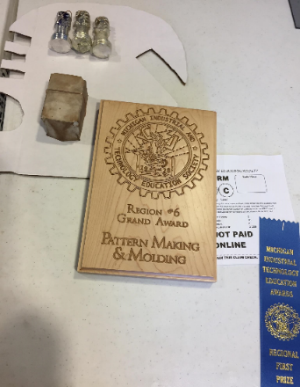
- Congrats to our MITES Regional Award Winners in Graphic Design – SEE ATTACHMENT

- Congrats to FHS Marketing students who won FIRST Place at the Michigan Schools & Government Credit Union Marketing Competition-Ashton Rea, Nazim Ullah, Fahmida Rahman and Julia Ciccone
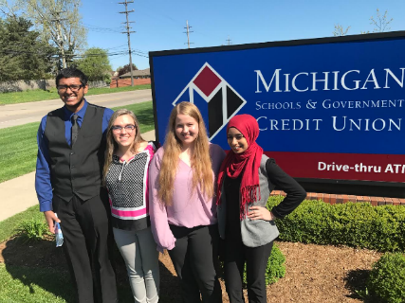

SMTEC News
- SMTEC CAD & Manufacturing programs hosted their first Annual Career Fair with local employers who interviewed graduating seniors for positions in their companies. Thank you to our wonderful employers: Jodi@Paslin, Rick@Eifel Mold & Engineering, Gary@True Industries, and Rob@Grant Group.

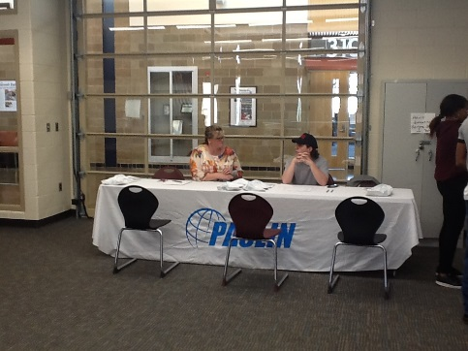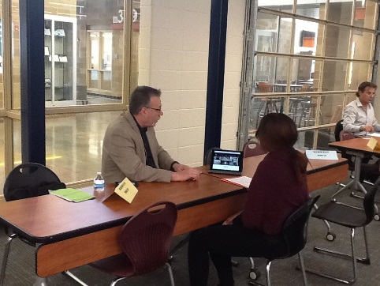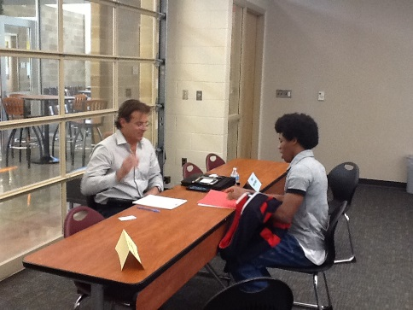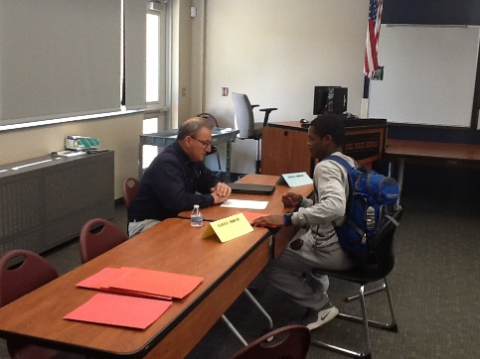
- Hats off to all our HOSA state competitors on advancing to the state competitions. We are proud of you!
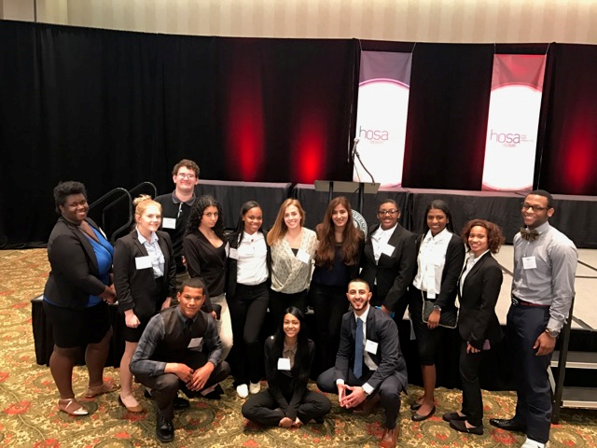
- So proud of our students who completed their 24 clinical hours at Shelby Crossing. Good luck on your state exam!
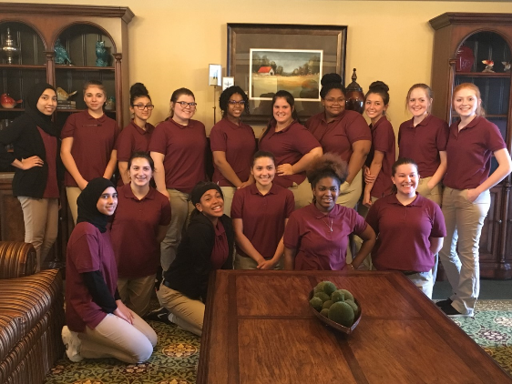

- SMTEC PT students visited Wright & Wright & Filippis. They had the opportunity to meet with amputees, prosthetists and technicians, see the labs, the training room and all variations of prostheses. Awesome trip!
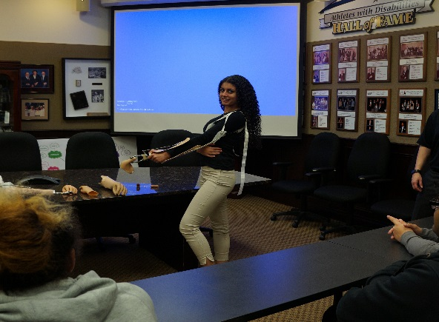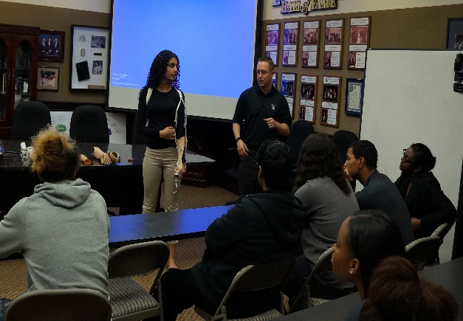
SMTEC Teachers
- Reminder—CIP Self Review DEADLINE EXTENDED TO 5/31/17. Please email me if you need assistance. Remember, our audit next year is based on what is uploaded this year!

CTE Resources
- Shannon Williams, our new CTE Consultant at MISD will be offering a CIP Self Review & CTE Navigator Training on May 24th from 3-5 in the MISD Distance Learning Lab. If interested, please RSVP to Heather Shellenbarger at (586) 228-3493 or email her at: hshellenbarger@misd.net

Upcoming Dates
- May 18th-Wayne State University-Nursing & Engineering fieldtrip
- May 19th-NTHS Induction & Award Ceremony-FHS CTE Building-7:30-9:00 am
- May 19th-Selfridge fieldtrip
- May 22nd-Advisor’s Meeting 12:30 p.m.
- May 24th-Cosmetology Parent Meeting @ Ed Center-6-7:30

K:\District\SMTEC\16-17-Snapshot\Snapshot-5-18-17.docx

