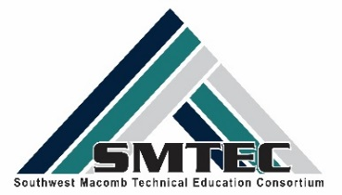
YEAR IN REVIEW 2017-2018

Points of Pride
Over 2100 students enrolled in CTE courses
Purchase of Anatomage 3D Dissection Table for Health Science students at WWT
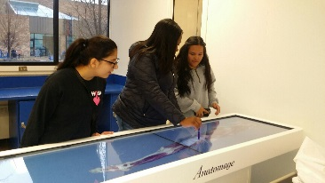
New equipment for Manufacturing students includes: Lathe, EDM Wire, and Faro Arm Scanner at LHS
Early Middle College-Medical Assistant cohort completed 10 direct college credits
National HOSA Competitor in Physical Therapy
Grants awarded:
- 61c Competitive Grant Awards for Manufacturing and Welding/Pre-Apprenticeship, totaling over $400K;
- IT Summer Camps for 60 students in partnership with Macomb Community College-Ralph Wilson Foundation
- C2Pipeline partnership with Wayne State University for the 2018-19 school year
Thirteen NTHS Seniors earned Graduation Stoles and/or Honor Cords
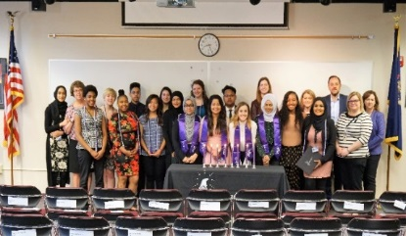
College Readiness – Over 741 students visited college campuses
Art Institute- Culinary School Baker College
Clearly University Culinary Institute of Michigan
Davenport University Lansing Community College
Lincoln Tech Macomb Community College
Michigan State University MIAT College
Oakland University Schoolcraft College
Wayne State University Universal Technical Institute
University of Detroit Mercy University of Ohio Tech
University of Michigan UTI College

Career Readiness-1002 visits with 28 partners
Ascension Health System City of Sterling Heights Mass Casualty Drill
Detroit Mercy Dental School DMG Mori TEC Days
Eifel Mold & Engineering Ford Field Education Day
General Motors Grant Group
GM Heritage Museum Henry Ford Museum
Industry Source Little Caesar’s Arena
Manufacturer’s Engage Michigan Defense Expo Exhibitors
Midwest Mold Mobile Dentistry Unit
Motion Picture Institute Olson Dental
Paragon Industries Providence Hospital
Selfridge Air National Guard Shelby Crossing Assisted Living Center
St. John Hospital The Whitney
TNG-Worldwide Whitlam Label
Wright & Fillipis
Siemens Corporation-Manufacturing in America

Volunteer/Community Service
Gleaners Food Pantry
Salvation Army
Turning Points Fundraiser & Donation
Warren Woods Public Library
Get WISE
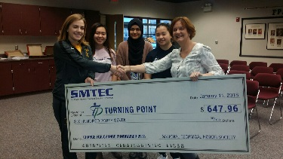

Student Competitions, Awards, or Events
American Society of Body Engineers Design Competition-LHS
- Best of School
Auto STEAM Days-Macomb Community College
Cosmetology Up Do & Fantasy Make-Up Contests
Courageous Persuaders Video Competition
- First Place Finalist-FHS
Distributive Education Clubs of America-WWT
- State Qualifiers
Early College Leadership Conference-Lansing Community College
Future DOcs Program-Michigan State University
Macomb Community College Elevator Pitch Competition-WWT
- First, Second & Third Place Awards
Manufacturing Day Video Competition-FHS
Meal Ready Culinary Competition-US Armed Forces-LHS
Michigan Schools & Government CU Dessert Competition-LHS & WWT
- Third Place Award-WWT
Michigan Industrial Technology Education Society (MITES)-LHS
- First, Second & Third Place State Awards
North American International Auto Show Poster Competition-CLHS
Health Occupation Student Association (HOSA)-CLHS, FHS, LHS, WWT
- State Qualifiers
- National Qualifier in Physical Therapy-FHS
- MED Talks
ROTC Dining Out Event
Seventh Brigade Drill Competition-CLHS
Skills USA-CL, LHS
- State Qualifiers
- Bronze Medal Winners in Law Enforcement-CLHS
US CTE Presidential Scholar Michigan Nominee
- Student in Law Enforcement Program

